

Problem: Problem: Draw the following fan using the Mid Point Circle algorithm and Bresenham algorithm.

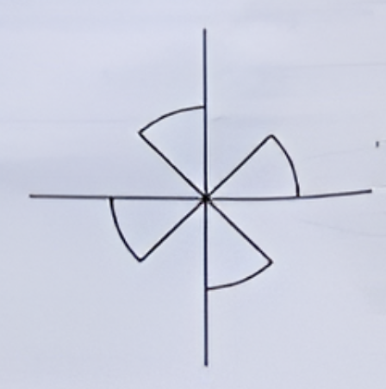

Code :

#include <GL/glut.h>
#include <math.h>
#include <stdlib.h>

int xc = 0, yc = 0, r = 7;
void drawLine(int x0, int y0, int x1, int y1) {
int dx = abs(x1 - x0), dy = abs(y1 - y0);
int sx = (x0 < x1) ? 1 : -1;
int sy = (y0 < y1) ? 1 : -1;
int err = dx - dy;

glBegin(GL_POINTS);
while (1) {
glVertex2i(x0, y0);

if (x0 == x1 && y0 == y1)
break;

int e2 = 2 * err;
if (e2 > -dy) {
err -= dy;
x0 += sx;
}
if (e2 < dx) {
err += dx;
y0 += sy;
}
}
glEnd();
}

void drawArcs() {
int x = 0, y = r;
int d = 1 - r;

glBegin(GL_POINTS);
while (x <= y) {
glVertex2i(xc + y, yc + x);
glVertex2i(xc - x, yc + y);
glVertex2i(xc - y, yc - x);
glVertex2i(xc + x, yc - y);

if (d < 0) {
d += 2 * x + 3;
} else {
d += 2 * (x - y) + 5;
y--;
}
x++;
}
glEnd();
}

void display() {
glClear(GL_COLOR_BUFFER_BIT);

glColor3f(1.0, 1.0, 1.0);

drawLine(-12, 0, 12, 0);
drawLine(0, -12, 0, 12);

int d = (int)(r / sqrt(2.0));

drawLine(xc, yc, xc + d, yc + d);
drawLine(xc, yc, xc - d, yc + d);
drawLine(xc, yc, xc - d, yc - d);
drawLine(xc, yc, xc + d, yc - d);
drawArcs();

glFlush();
}

void init() {
glClearColor(0.0, 0.0, 0.0, 1.0);
glPointSize(6.0);
glEnable(GL_POINT_SMOOTH);
glEnable(GL_BLEND);
glBlendFunc(GL_SRC_ALPHA, GL_ONE_MINUS_SRC_ALPHA);

glMatrixMode(GL_PROJECTION);
glLoadIdentity();
glOrtho(-14, 14, -14, 14, -1, 1);
}

int main(int argc, char **argv) {
glutInit(&argc, argv);
glutInitDisplayMode(GLUT_SINGLE | GLUT_RGB);
glutInitWindowSize(700, 700);
glutCreateWindow("Improved Fan Shape");
init();
glutDisplayFunc(display);
glutMainLoop();
return 0;
}

Output:

